**Name – Ravi Kumar**

**Roll no – 244CA041**

**Assignment 2**

1. **Retrieve the names of all instructors who teach at least one course in the 'Computer Science' department.**

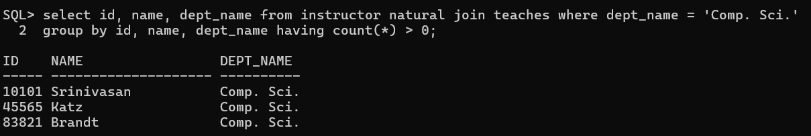

1. **List all students who have taken at least one course in 'Fall' and 'Spring' semesters in the same year.**

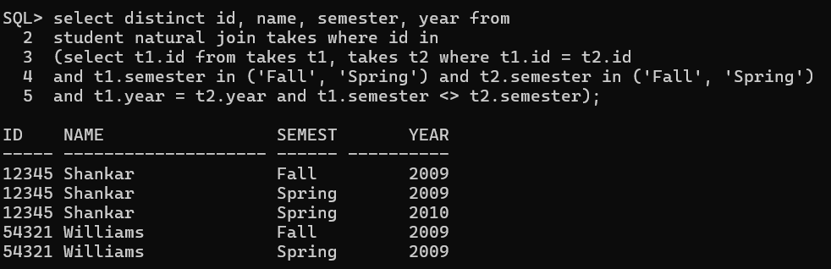

1. **Find all classrooms that have a capacity of more than 100 but are not assigned to any section.**

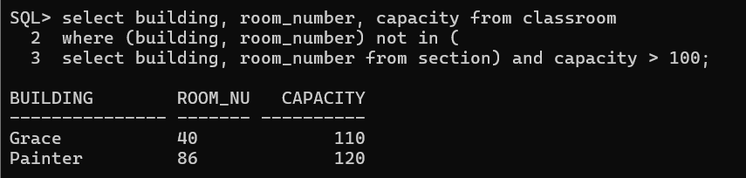

1. **Display all courses along with their prerequisites, including courses that have no prerequisites.**

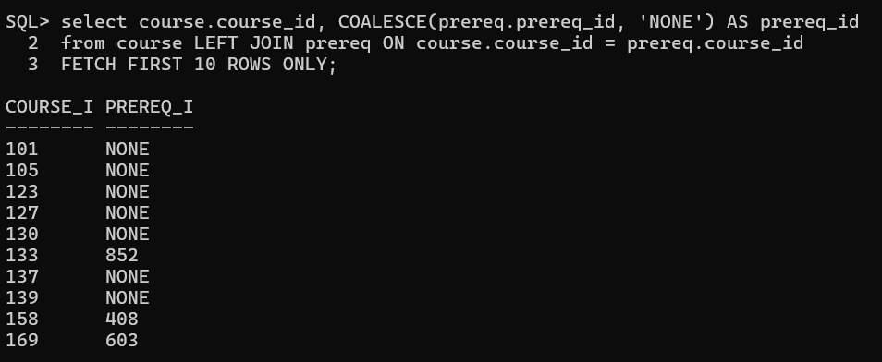

1. **Retrieve the list of instructors who have never taught a course.**

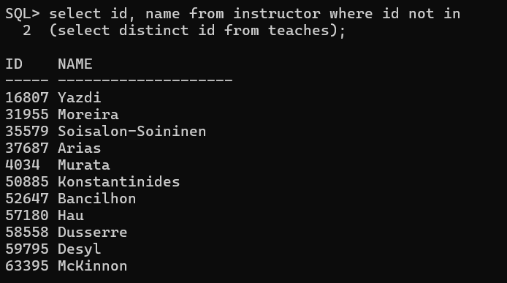

1. **Find the total budget allocated to all departments that have at least one instructor earning more than ₹100,000.**

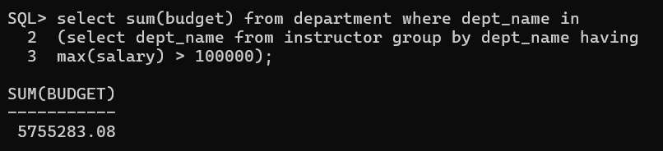

1. **Find the average salary of instructors grouped by department but only include departments with more than 5 instructors.**

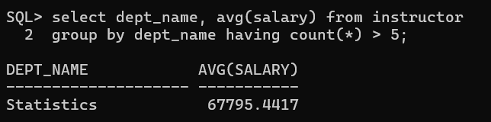

1. **Find the total number of students enrolled in each course for every semester, and sort by semester and number of students (descending).**

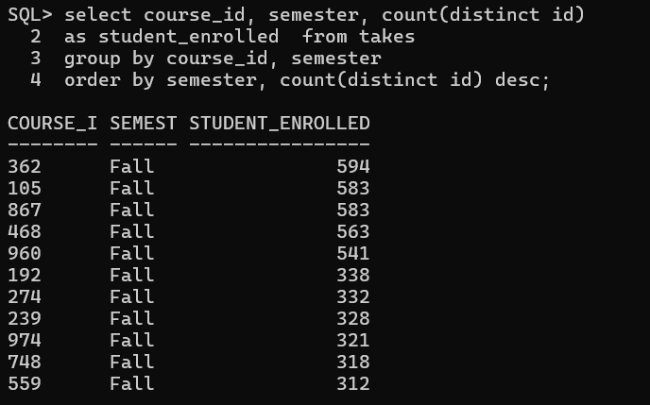

1. **Determine which department has the highest average course credit.**

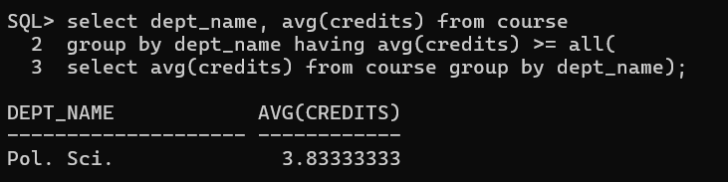

1. **Find the top 3 courses with the most students enrolled across all semesters.**

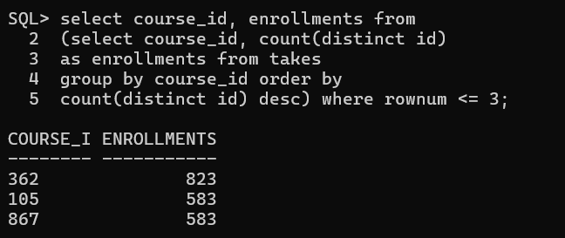

1. **Find all students who have taken every course taught by the instructor 'John Doe'.**

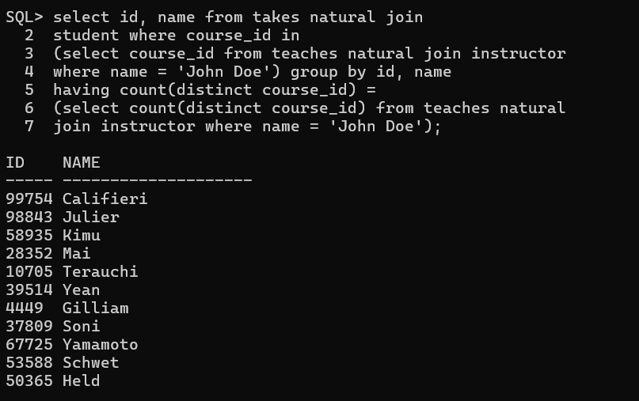

1. **Retrieve the names of students who have the same name as their advisor.**

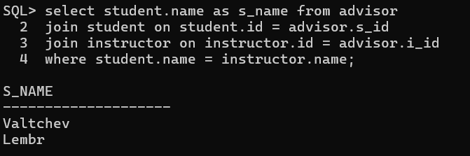

1. **Find all instructors who have taught at least one course that they did not belong to the department of.**

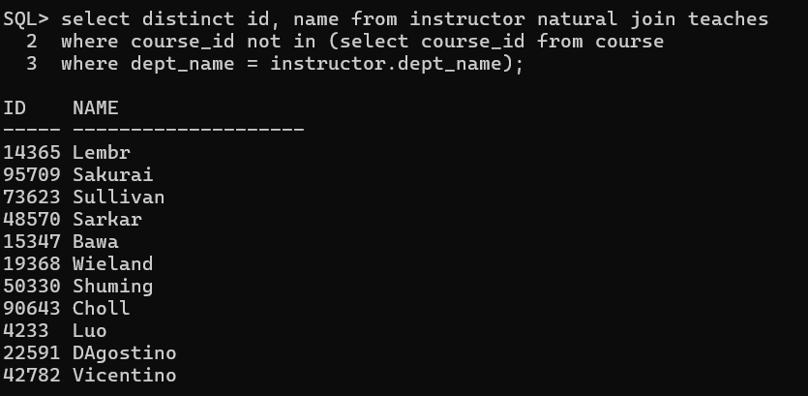

1. **List all students who have taken a course in a classroom that has a capacity less than the number of students enrolled.**

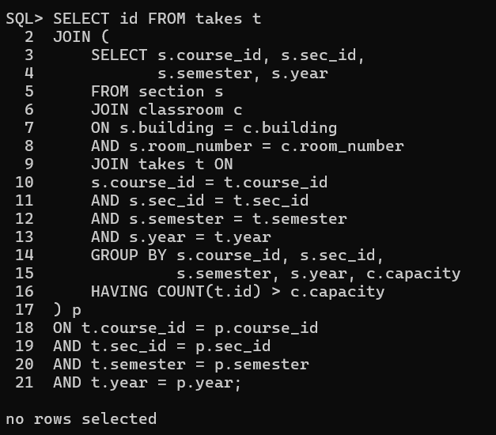

1. **Find students who have taken every course offered by their department.**

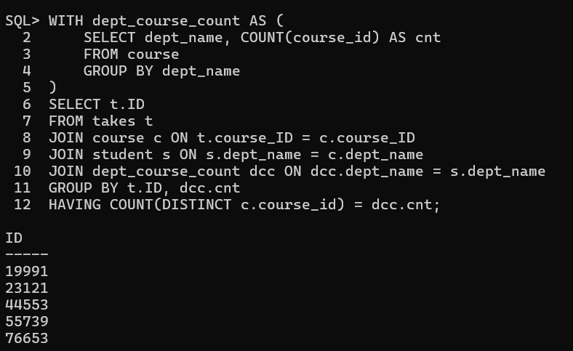

1. **Identify the department(s) with the largest number of distinct courses offered.**

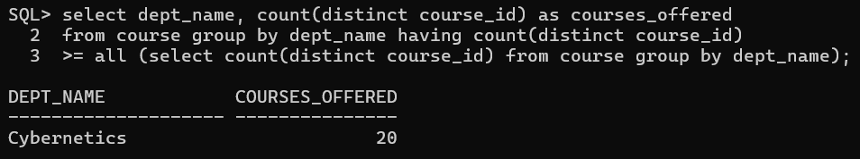

1. **Find students who have taken a course but have not received a grade.**

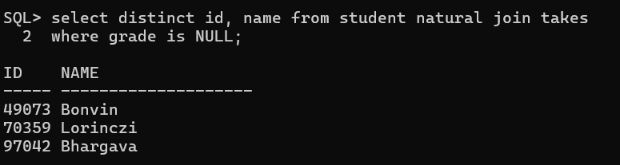

1. **Retrieve the details of instructors who have the exact same salary as another instructor.**

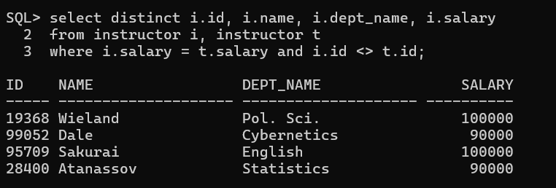

1. **Identify all courses that have prerequisites, but the prerequisite itself has no**

**prerequisite.**

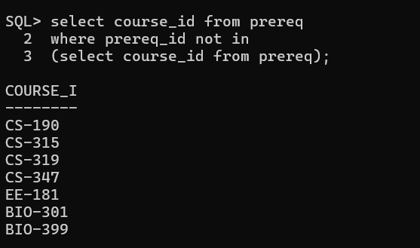

1. **Find all students who have taken courses in every semester (Fall, Spring)**

**at least once.**

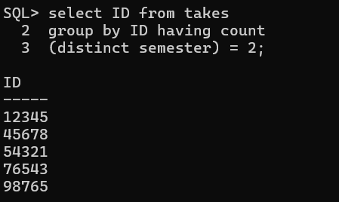

1. **Identify students who have taken a course whose prerequisite they have never**

**taken.**

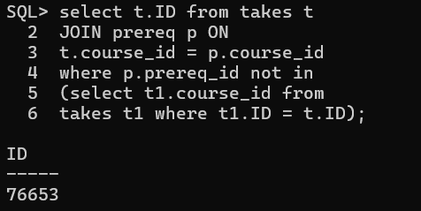

1. **Find all instructors who have taught a course that has another course as a**

**prerequisite.**

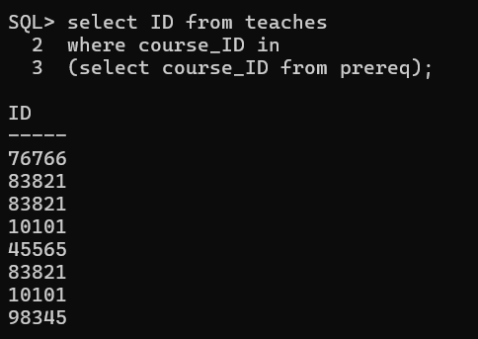

1. **Find all students who have the same total credits as another student in a different**

**department.**

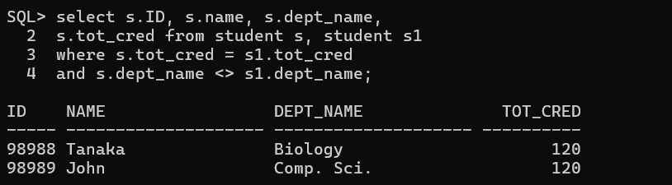

1. **Identify instructors who have the highest salary in their department but still earn**

**less than the highest salary in another department.**

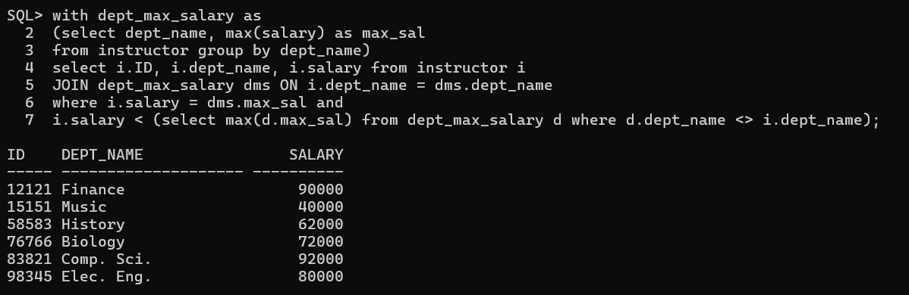

1. **List all departments where the highest-paid instructor earns more than the total**

**department budget divided by the number of instructors.**

